MR Stelios Hadjichristofis did his initial Medical degree in Sofia, Bulgaria where he learnt the language and studied Russian language for three years. He got his diploma in Medicine with excellent result. Then he did the medical exams in Athens Greece for recognition of his medical degree. He did after that 11 months internship in the hospitals in Cyprus and before he finished his time, he moved to South Africa where he wrote entrance exams for registration with the SAMDC (South African Medical Council) and repeated his internship for 12 months in Hammanskral Hospital. Then he moved in one of the best Academic Hospitals in Johannesburg -Hilbrow General Hospital where he worked as SHO (Senior House Officer) for six months in Orthopaedic Surgical Department. Then he continued in the same department as Medical Officer and then senior Medical officer for the following 18 months. Within that time, he wrote the Part I examination for Fellowship in the college of Surgeons of South Africa(FCS(SA) I) – Orthopaedics so to be eligible for Registrar position and specialization in Orthopaedics. He successfully completed FCS(SA) I and started his time of specialization in the University of the Witwatersrand - initially one year General Surgery in the Academic University of Baragwanath ( Chris Hani Baragwanath Hospital founded 1948. The largest hospital in the southern hemisphere and the third largest in the world.) and then 4 years Orthopaedics in four Academic Hospitals – Johannesburg General Hospital, J.G. Strydom Hospital, Hilbrow General Hospital and Baragwanath Hospital – all in Johannesburg. Halfway in the speciality he wrote Successfully the FCS(SA) Part II examination for Fellowship in the college of Surgeons of South Africa – Orthopaedics – an extremely difficult exam. Also, he successfully completed a course in Research Techniques (EXPD 701) in the University of the Witwatersrand – Continuing Education. At the end of his training he successfully completed Specialist Orthopaedic exam in Athens, Greece and registered as a specialist Orthopaedic Surgeon by the Department of Hygiene in the Hellenic Republic. Finally, after he completed his training time he Successfully completed FCS (SA) Orthopaedics (final exam) to become Fellow of the College of Surgeons of South Africa – an extremely difficult examination. At the same time, he was awarded the SYNTHES prize for the best Orthopaedic Registrar in the Johannesburg Group of Teaching Hospitals, who is deemed to have contributed most to the department of the Orthopaedic surgery, for academic achievement and for clinical excellence. He also received the SAHETI (South African Hellenic Educational and Technical Institute), award for outstanding postgraduate. He was also awarded the Smith & Nephew Arthroscopy local traveling bursary to improve skills and knowledge on the Arthroscopic Surgical techniques and immediately afterwards the Smith & Nephew Overseas travelling grant in Arthroscopic Surgery and he spent time in the Arthroscopic and sport centres in Boston (Massachusetts General Hospital and Harvard University) and Pittsburgh University in the United states of America. Then he was again spent time in the United states of America participating in the Educational Exchange program organised by the international centre for Orthopaedic education in association with the American Academy of Orthopaedic Surgeons and the American Orthopaedic Association - visiting prominent orthopaedic centres in San Francisco and Los Angeles, USA.
CV of Dr Stelios Hadjichristofis. FCS(SA)Orth. / MMed(WITS)Orth. Orthopaedic Surgeon.

Two years after his final orthopaedic exams he was awarded the degree of MMed (Master of Medicine) in Orthopaedic Surgery for the successful completion of his thesis prescribed for this degree and for the research report entitled: The Prevalence of Osteoporosis in Primary Osteoarthritis – Practical and Theoretical Significance.
Immediately after his final exams in Orthopaedics he was offered a consultant Specialist Orthopaedic Surgeon post in the Orthopaedic department of the academic Hospital – Johannesburg General Hospital. He was involved with major Trauma cases as it was a referral tertiary orthopaedic unit. He was doing and teaching arthroplasty of knee and hip joints and also arthroscopic surgery. At the same time there were doing a lot of work and research about MIS (Minimally Invasive surgery). Within a year he became acting head of the Arthroscopy, knee unit in the department of Orthopaedic surgery. During that time, he wrote and presented many papers in congresses and meetings, he was teaching medical students and also orthopaedic registrars for specialization in Orthopaedics. He also participated in many international meetings and congresses and he visited many workshops for new technology and advance surgical techniques. By the end of his time in the Academic Hospital he did the international degree in ATLS, Advanced Trauma Life Support a prerequisite to be in the team of Level 1 trauma in Academic or Private Hospital.
During that time he became member of the Orthopaedic Association of South Africa; Member of the Arthroscopy and Sport Injuries Society-SA; Member of the Arthroplasty society – SA, Member of the AO ALUMNI Association for the Study of Internal Fixation (ASIF); Affiliate member of the American Academy of Orthopaedic Surgeons – AAOS. At later stage he became Member of ESSKA (European Society of Sports Traumatology, Knee surgery and Arthroscopy); and Member of ISAKOS (International Society of Arthroscopy, Knee Surgery and Orthopaedic sports
After he completed about 13 years in the Academic Hospitals as Registrar and Consultant, he went to the private sector where he worked for 12 years at two Private hospitals, one of the largest hospitals in Africa and big trauma center Level 1 – Milpark Hospital and also a very advanced and reputable private Hospital – Bedford Gardens Hospital. At the beginning of his new career he got a diploma in Robotic knee arthroplasty and he did knee replacements with robotic techniques (computer assisted knee replacement or Navigation Arthroplasty) for 8 years. He followed all the developments in arthroplasty, arthroscopy and surgery of the knee, shoulder, Hip, elbow, hand and foot. The private hospital was tertiary referral center and got referrals from all over Africa. He had a very successful career in private medical practice in Johannesburg. All those years he stayed in touch with modern Orthopedic Medicine with two to three international conferences a year and two to three orthopaedic workshops for training and specialization in new methods and instruments. At the same time, he was teaching at the medical school of the University of the Witwatersrand medical students and Orthopaedic Registrars. He also participated as an Instructor in the AO International advanced courses in Trauma – Davos, Switzerland twice and also in the AO Masters Course - Trauma Masters symposium – Davos, Switzerland.
After he spent 25 years in Johannesburg South Africa and had a very successful career in Academic and Private Hospitals, he is back to Cyprus for 8 years now where he worked at Apollonion Hospital in Nicosia for seven years and since November 2021 he works in American Medical Center where he offers his experience and his skills to the public. By the time he is in Cyprus he has done extremely difficult cases with great success and a wish that this become known to everybody in Cyprus. He can help in decisions making about the preferred treatment within the latest developments and also in performing difficult surgery. Some of the cases that he did surgery upon were permitted to go overseas for treatment on government expenses. Besides the experience and skills that he brought from his long-term stay abroad he continued to remain close to the developments of modern Orthopaedics with international conferences and workshops for new methods in America and in Europe. He has already registered the new Custom made implant for Knee Arthroplasty (VISIONAIRE) with a prerequisite an MRI and special x-rays of the lower limbs that the X-ray department of the American Medical Center is fully prepared to do that. It will take only 6 weeks for ordering the instruments from Switzerland.

In summary after he spent 25 years in Johannesburg in South Africa where he did his specialty and his thesis in Orthopedics at one of the best medical schools in the world at the time - Medical school of the university of the Witwatersrand. Those much difficult exams and difficult dissertation along with the very difficult and demanding training in academic hospitals made the foundations for high quality orthopaedic Surgeons. After the acquisition of an extremely difficult specialty he was a Consultant and head of the Orthopedic Department of the knee and Arthroscopy in the Academic Hospital of the University of the Witwatersrand Johannesburg General Hospital) where he worked for the following 5 years. In those years he perfected his skills in Trauma, in Arthroscopy, in Arthroplasty and foot and hand Surgery. He also did diplomas in Research, ATLS (Advanced Trauma Life Support), Robotic knee arthroplasty and at later stage custom-made knee replacement. He also wrote the Greek exams for basic degree and Orthopedic degree for recognition in Greece.
At the moment his rooms are in the American Medical Center – Room 105. Tel. 00357 22476874.
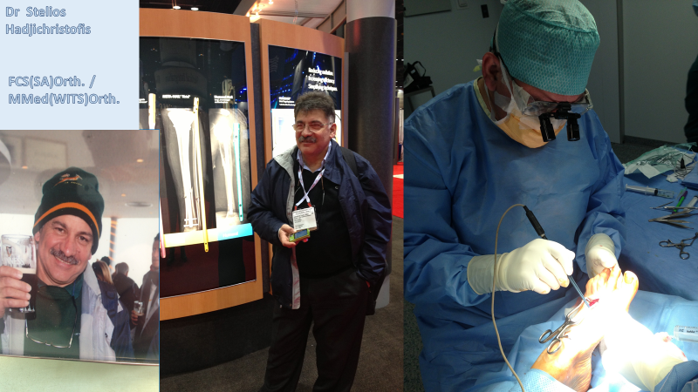
He can offer high quality services with honesty. You will get advice that will be at high level comparing anywhere in the world. Medicine is a science of logic using the correct knowledge. Logical thinking based on correct information. In the times we live where marketing is taking over from real honest medicine you need a good honest advice.

============================================================================

Mr Stelios Hadjichristofis FCS(SA)Orth. / MMed(WITS)Orth.

ORTHOPAEDIC SURGEON – Trauma, Sport Trauma, Arthroplasty, Arthroscopy,Hand & Foot surgery

Fellow of the College of Medicine of South Africa - FCS(SA)Orth.

Master of Medicine in Orthopaedics – University of Witwatersrand - MMed(WITS)Orth.

Member of the South African Orthopaedic Association

Affiliate Member of the American Academy of Orthopaedic Surgeons

Member of ESSKA (European Society of Sports Traumatology Knee surgery and Arthroscopy)

Member of ISAKOS(International Society of Arthroscopy, Knee Surgery and Orthopaedic sports Medicine)

Orthopaedic specialist – Greece, Athens

Senior Lecturer at the University of Witwatersrand Medical school - Johannesburg
e-mail: hadjichristofis.stelios@cytanet.com.cy
AMERICAN MEDICAL CENTER
cell: 00357 99722555 web: www.bonejointcyprus.com
Phone: 22476874

